Entity-Relationship Diagramming Explained

Introduction

An entity-relationship diagram, or “ERD,” is a model that identifies the concepts or entities that exist in a system and the relationships between those entities. An ERD is often used as a way to visualize a relational database: each entity represents a database table, and the relationship lines represent the keys in one table that point to specific records in related tables. ERD’s assist in the database design process as they provide a tangible means for communication between the database designer and the database end users. An ERD also provides documentation for later examination of the features of the database and for explaining design decisions.

Understanding the Model

There are several different modeling systems for entity relationship diagramming. This ERD is presented in the “Information Engineering” style. Those unfamiliar with entity relationship diagramming or unfamiliar with this style of notation may wish to consult the following section to clarify the diagramming symbols.

Entities

Entities are “items” or “concepts” within the data model. Each entity is represented by a box within the ERD. Entities represent one or more instances of the item or concept in question. An entity might be considered a container that holds all of the instances of a particular thing in a system. Entities are equivalent to database tables in a relational database, with each row of the table representing an instance of that entity.

The diagram below has an entity for “student” and another for “school.” This indicates that the system being modeled may contain one or more students and one or more schools.



So far, no relationship between students and schools has been indicated.

Relationships

Relationships are represented by lines between entities. Relationship lines indicate that each instance of an entity may have a relationship with instances of the connected entity, and vice versa.



The diagram above now indicates that students may have some relationship with schools. More specifically, there may be a relationship between a particular student (an instance of the student entity) and a particular school (an instance of the school entity).

If necessary, a relationship line may be labeled to define the relationship. In this case, one can infer that a student may attend a school, or that a school may enroll students. But if necessary, this relationship could be labeled for clarification:



Read the first relationship definition, “attends,” when tracing the relationship left to right or top to bottom. Read the second definition, “enrolls,” when tracing the relationship right to left or bottom to top.

Optionality and Cardinality

Symbols at the ends of the relationship lines indicate the optionality and the cardinality of each relationship. “Optionality” expresses whether the relationship is optional or mandatory. “Cardinality” expresses the maximum number of relationships.

As a relationship line is followed from an entity to another, near the related entity two symbols will appear. The first of those is the optionality indicator. A circle (  ) indicates that the relationship is optional—the minimum number of relationships between each instance of the first entity and instances of the related entity is zero. One can think of the circle as a zero, or a letter O for “optional.” A stroke ( | ) indicates that the relationship is mandatory—the minimum number of relationships between each instance of the first entity and instances of the related entity is one.

The second symbol indicates cardinality. A stroke ( | ) indicates that the maximum number of relationships is one. A “crows-foot” ( ) indicates that many such relationships between instances of the related entities might exist.

The following diagram indicates all of the possible combinations:

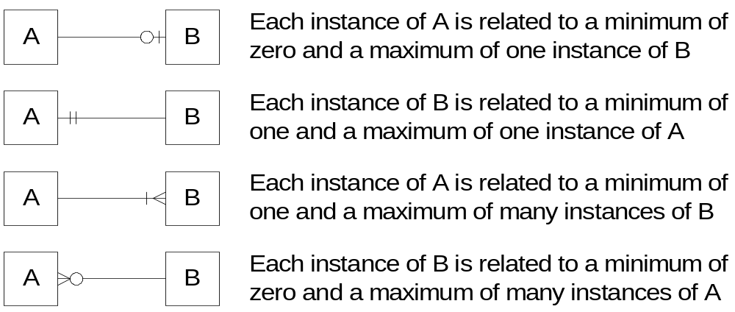

In our model, we wish to indicate that each school may enroll many students, or may not enroll any students at all. We also wish to indicate that each student attends exactly one school. The following diagram indicates this optionality and cardinality:

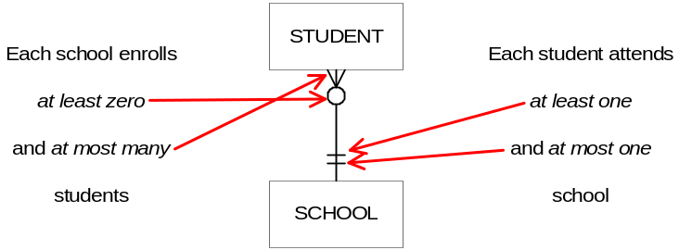

It is important to note that relationship optionality and cardinality constraints apply specifically to the system being modeled, not to all possible systems. According to the example modeled above, a school might not enroll any students—that relationship is optional. A school without students is not much of a school, but this is what this particular application requires. Consider the function of the system and consult the other documents in the data model to clarify modeling decisions.

Assocative Entities

When an instance of an entity may be related to multiple instances of another entity and vice versa, that is called a “many-to-many relationship.” In the example below, a supplier may provide many different products, and each type of product may be offered by many suppliers:

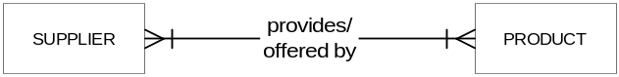

While this relationship model is perfectly valid, it cannot be translated directly into a relational database design. In a relational database, relationships are expressed by keys in a table column that point to the correct instance in the related table. A many-to-many relationship does not allow this relationship expression, because each record in each table might have to point to multiple records in the other table.

In order to build a relational database that captures this relationship, it is necessary to build a bridge between the two entities that uniquely expresses each relationship instance. This can be modeled in an ERD with an “asssociative entity,” an entity box containing a diamond, which may replace the many-to-many relationship. (The diamond is used in other ER modeling systems to indicate relationships, or may be viewed as the associating—the bridge—of the many-to-many “crows-feet”).

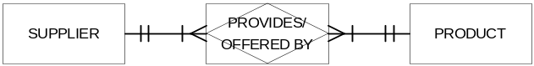

This diagram expresses the same relationship as the diagram above. Each instance of the “provides” associative entity indicates that a certain supplier can provide a certain product.

Recursive Relationships

Instances of entities may have relationships with other instances of the same entity. These relationships may be drawn with relationship lines that begin and end connected to the same entity. Common occurrences of these recursive relationships include parent/child relationships:

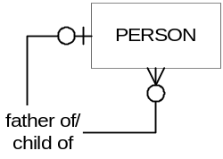

The diagram above indicates that a person may be the father of zero or many persons, and that a person may have zero or one father. (Not every person’s father will be recorded in the system, so the relationship is modeled as optional).

Multiple Relationships Between Entities

An entity may have multiple relationships with another entity. These are depicted in the ERD with multiple relationship lines connecting the two entities

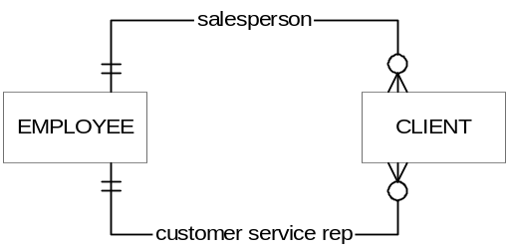

The diagram above indicates that an employee may be the salesperson assigned to zero or many clients, and an employee may be the customer service representative for zero or many clients. Each client has exactly one salesperson and exactly one customer service representative. Each client’s salesperson may or may not be the same employee as the client’s customer service representative; each relationship is treated independently.

Conclusion

An entity-relationship diagram is a design tool that depicts the major entities and relationships needed for designing a new database system. It will assist developers with envisioning the complexity of the database, and ensure that crucial relationships and features will be included in final implementation.

